# Project Development Phase SPRINT-1

|  |  |
| --- | --- |
| Date | 08 november 2022 |
| Team ID | PNT2022TMID41904 |
| Project Name | Project - IOT Based Safety Gadget for Child Safety Monitoring & Notification |

* **REGISTRATION:**

# HTML:

<!DOCTYPE html>

<html lang="en">

<head>

<meta charset="UTF-8">

<meta http-equiv="X-UA-Compatible" content="IE=edge">

<meta name="viewport" content="width=device-width, initial-scale=1.0">

<link rel="stylesheet" href="/css/login.css">

<title>Sign Up</title>

<script>

if (window.location.hostname !== "localhost") { if (location.protocol !== "https:") {

location.replace(

`https:${location.href.substring( location.protocol.length

)}`

)

}

}

</script>

<script src="./localforage.js"></script>

</head>

<body>

<div class="wrapper">

<div class="loginContainer">

<span>Login to Continue</span>

<div class="traditionalLoginContainer">

<form class="signupForm" action="/" method="post">

<input type="text" name="firstName" placeholder="First Name" id="firstName">

<input type="text" name="lastName" placeholder="Last Name" id="lastName">

<input type="text" name="username" placeholder="User Name" id="username">

<input type="email" name="email" placeholder="Email" id="email">

<input type="password" name="password" placeholder="Password" id="password">

<input class="loginButton" type="submit" value="Sign Up">

</form>

</div>

<div class="loginWithFireContainer">

<button type="button" class="fire" title="Login with SAFETY" id="fire">Login with SAFETY</button>

</div>

<a class="hyperLink" href="/login">Already have an Account? Login ↗</a>

</div>

</div>

<script>

// Necessary for Fire OAuth to Function

const fireBroadcastingChannel = new BroadcastChannel('fireOAuthChannel'); fireBroadcastingChannel.addEventListener('message', async event => {

let data = event.data

/**

* **@typedef {Object<string, any>} Data**
* **@property {boolean} success - Whether the login was successful**
* **@property {string} token - The data returned from the login i.e. Fire Token**

*/

// data.token is the message sent from the fireOAuthChannel after verification

// data.success is a boolean that indicates whether the verification was successful

// data.token is the fire token

// What to do with the Fire Token?

// * Fire Token is an unique token which uniquely identifies the user who authorized your login attempt with Fire

// * You can use this token ONLY ONCE as it will be destroyed after the first use

// 1. Send the fire token to the Fire Server to verify the user

// - You can do that client sided or server sided

// - You need to send a POST Request to the Fire Server with the fire token

// at the URL: http://localhost:3003/api/tokens/verify

// - The Fire Server will verify the fire token and return a response

// - If the verification was successful - CODE (200), the Fire Server will return a response with the user's data

// - If the verification was unsuccessful - CODE (400) or CODE (401), the Fire Server will return a response with an error 'message'

// - You can use the data returned from the Fire Server to create a new user in your database

// This example will send the token to Fire Servers and console.log the response console.log("%c" + `Fire Token: ${data.token}`, `color: #f1c40f; font-weight: bold;`);

const response = await fetch('https://fire.adaptable.app/api/tokens/verify', { method: 'POST',

headers: {

'Content-Type': 'application/json'

},

body: JSON.stringify({ token: data.token

})

})

// get the response

const responseData = await response.json()

// console.log the response console.log(responseData)

await localforage.setItem('userData', {...responseData, isFire: true})

// Adding the user data to the user Database

let database = await localforage.getItem("userDatabase") if (database == null) {

database = []

}

database.push(responseData)

await localforage.setItem("userDatabase", database)

// redirect to the home page window.location.href = '/'

})

function popupwindow(url, title, w, h) { var left = (screen.width/2)-(w/2);

var top = (screen.height/2)-(h/2);

return window.open(url, title, 'toolbar=no, location=no, directories=no, status=no, menubar=no, scrollbars=no, resizable=no, copyhistory=no, width='+w+', height='+h+', top='+top+', left='+left);

}

document.getElementById("fire").addEventListener("click", function() { popupwindow("/fireoauth.html", "Fire OAuth", 450, 600)

})

</script>

<script>

// this.Website's Scripts / App Logic document.querySelector(".signupForm").addEventListener("submit" , async (e) => {

e.preventDefault()

let firstName = document.getElementById("firstName").value let lastName = document.getElementById("lastName").value let username = document.getElementById("username").value

let email = document.getElementById("email").value

let password = document.getElementById("password").value let profilePic = `https://avatars.dicebear.com/api/adventurer-

neutral/${firstName}${lastName}.svg?backgroundColor=variant03`

let data = { firstName, lastName, username, email, password, profilePic } await localforage.setItem("userData", data)

let database = await localforage.getItem("userDatabase") if (database == null) {

database = []

}

database.push(data)

await localforage.setItem("userDatabase", database) window.location.href = "/"

})

</script>

</body>

</html>

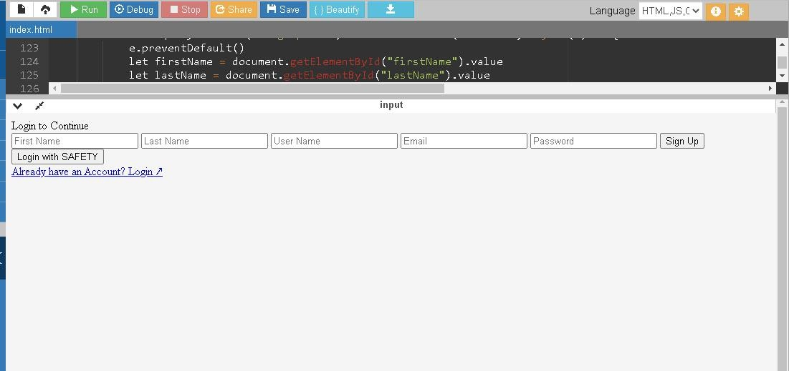

# CONFIRMATION EMAIL: INDEX:

<!DOCTYPE html>

<html lang="en" style="height: 100%; margin: 0;">

<head>

<meta charset="UTF-8" />

<meta name="description" content="The Home Page after Logged In" />

<meta name="viewport" content="width=device-width, initial-scale=1.0" />

<title>IOT Based Safety Gadget for Child Safety Monitoring and Notification</title>

<script src="./localforage.js"></script>

<script>

if (window.location.hostname !== "localhost") { if (location.protocol !== "https:") {

location.replace(

`https:${location.href.substring(

location.protocol.length

)}`

)

}

}

async function check() { let data = localforage.getItem("userData") if (data == null) {

window.location.href = "/login"

}

}

check()

</script>

</head>

<body

style="

height: 100%;

margin: 0;

font-weight: 300;

font-family: -apple-system, BlinkMacSystemFont, 'Segoe UI', Roboto, Oxygen, Ubuntu, Cantarell, 'Open Sans', 'Helvetica Neue',

sans-serif;

"

>

<div

class="wrapper"

style="

height: 90%; display: flex;

flex-direction: column;

align-items: center; justify-content: center;

text-align: center;

"

>

<div

class="details" style="

display: flex;

flex-direction: column; align-items: center; gap: 20px;

padding: 1rem; border-radius: 5px;

box-shadow: 0 0 8px 0px #44444444;

max-width: 80%;

"

>

<h1 class="name" style="margin: 0"></h1>

<div

class="imageContainer"

style="padding: 10px; height: 10rem; width: 10rem"

>

</div>

<img class="image" alt="profile picture" />

<h2 class="email" style="margin: 0"></h2>

<a style="text-decoration: none;text-align: center;font-size: 1.2rem;color: #0070f3;font-weight: 400;" href="./dashboard">Go to Dashboard ↗</a>

</div>

<script>

</div>

async function main() {

let name = document.querySelector(".name") let image = document.querySelector(".image") let email = document.querySelector(".email")

let userData = await localforage.getItem("userData") if(userData == null) {

window.location.href = "/login"

}

name.innerHTML = `Welcome ${userData.firstName} ${userData.lastName}!` image.src = userData.profilePic

email.innerHTML = `Your email is: <a style="text-decoration: none;color: #0072B5;" href="mailto:${userData.email}">${userData.email}</a>`

}

main()

</body>

</html>

</script>

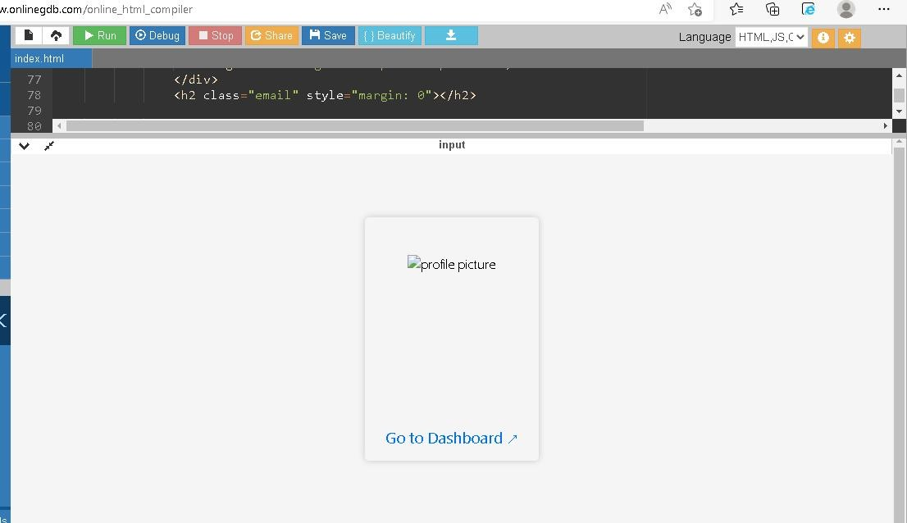

# LOCALFORAGE:

/*!

localForage -- Offline Storage, Improved Version 1.10.0 https://localforage.github.io/localForage

(c) 2013-2017 Mozilla, Apache License 2.0

*/

!function(a)

{if("object"==typeof exports&&"undefined"!=typeof module)module.exports=a(); else if("function"==typeof define&&define.amd)define([],a);

else{var b;

b="undefined"!=typeof window?window:"undefined"!=typeof global?global:"undefined"!=typeof self?self:this,b.localforage=a()}}(function(){

return function a(b,c,d){

function e(g,h){if(!c[g]){if(!b[g]){

var i="function"==typeof require&&require; if(!h&&i)return i(g,!0);if(f)return f(g,!0);

var j=new Error("Cannot find module '"+g+"'");

throw j.code="MODULE_NOT_FOUND",j}var k=c[g]={exports:{}}; b[g][0].call(k.exports,function(a){

var c=b[g][1][a];return e(c||a)},k,k.exports,a,b,c,d)} return c[g].exports}

for(var f="function"==typeof require&&require,g=0;g<d.length;g++)e(d[g]); return e}({1:[function(a,b,c){(function(a){"use strict";

function c(){k=!0;for(var a,b,c=l.length;c;){

for(b=l,l=[],a=-1;++a<c;)b[a]();c=l.length}k=!1} function d(a){1!==l.push(a)||k||e()}var

e,f=a.MutationObserver||a.WebKitMutationObserver;

if(f){var g=0,h=new f(c),i=a.document.createTextNode("");h.observe(i,{characterData:!0}),e=function(){i.data=g=++g%2}}

else if(a.setImmediate||void 0===a.MessageChannel)e="document"in a&&"onreadystatechange"in a.document.createElement("script")?function(){var b=a.document.createElement("script");b.onreadystatechange=function(){c(),b.onreadystatechange=null,b.pa rentNode.removeChild(b),b=null},a.document.documentElement.appendChild(b)}:function(){setTimeout(c,0)}; else{var j=new a.MessageChannel;j.port1.onmessage=c,e=function(){j.port2.postMessage(0)}}var k,l=[];b.exports=d}).call(this,"undefined"!=typeof global?global:"undefined"!=typeof self?self:"undefined"!=typeof window?window:{})},{}],2:[function(a,b,c){"use strict";function d(){}function e(a){if("function"!=typeof a)throw new TypeError("resolver must be a function");this.state=s,this.queue=[],this.outcome=void 0,a!==d&&i(this,a)}function f(a,b,c){this.promise=a,"function"==typeof b&&(this.onFulfilled=b,this.callFulfilled=this.otherCallFulfilled),"function"==typeof c&&(this.onRejected=c,this.callRejected=this.otherCallRejected)}function g(a,b,c){o(function(){var d;try{d=b(c)}catch(b){return p.reject(a,b)}d===a?p.reject(a,new TypeError("Cannot resolve promise with itself")):p.resolve(a,d)})}function h(a){var b=a&&a.then;if(a&&("object"==typeof a||"function"==typeof a)&&"function"==typeof b)return function(){b.apply(a,arguments)}}function i(a,b){function c(b){f||(f=!0,p.reject(a,b))}function d(b){f||(f=!0,p.resolve(a,b))}function e(){b(d,c)}var f=!1,g=j(e);"error"===g.status&&c(g.value)}function j(a,b){var c={};try{c.value=a(b),c.status="success"}catch(a){c.status="error",c.value=a}return c}function k(a){return a instanceof this?a:p.resolve(new this(d),a)}function l(a){var b=new this(d);return p.reject(b,a)}function m(a){function b(a,b){function d(a){g[b]=a,++h!==e||f||(f=!0,p.resolve(j,g))}c.resolve(a).then(d,function(a){f||(f=!0,p.reject(j,a))})}var c=this;if("[object Array]"!==Object.prototype.toString.call(a))return this.reject(new TypeError("must be an array"));var e=a.length,f=!1;if(!e)return this.resolve([]);for(var g=new Array(e),h=0,i=-1,j=new this(d);++i<e;)b(a[i],i);return j}function n(a){function b(a){c.resolve(a).then(function(a){f||(f=!0,p.resolve(h,a))},function(a){f||(f=!0,p.reject(h,a))})}var c=this;if("[object Array]"!==Object.prototype.toString.call(a))return this.reject(new TypeError("must be an array"));var e=a.length,f=!1;if(!e)return this.resolve([]);for(var g=-1,h=new this(d);++g<e;)b(a[g]);return h}var o=a(1),p={},q=["REJECTED"],r=["FULFILLED"],s=["PENDING"];b.exports=e,e.prototype.catch=function(a){ret urn this.then(null,a)},e.prototype.then=function(a,b){if("function"!=typeof a&&this.state===r||"function"!=typeof b&&this.state===q)return this;var c=new this.constructor(d);if(this.state!==s){g(c,this.state===r?a:b,this.outcome)}else this.queue.push(new f(c,a,b));return c},f.prototype.callFulfilled=function(a){p.resolve(this.promise,a)},f.prototype.otherCallFulfilled=function(a){g( this.promise,this.onFulfilled,a)},f.prototype.callRejected=function(a){p.reject(this.promise,a)},f.prototype.oth erCallRejected=function(a){g(this.promise,this.onRejected,a)},p.resolve=function(a,b){var c=j(h,b);if("error"===c.status)return p.reject(a,c.value);var d=c.value;if(d)i(a,d);else{a.state=r,a.outcome=b;for(var e=- 1,f=a.queue.length;++e<f;)a.queue[e].callFulfilled(b)}return a},p.reject=function(a,b){a.state=q,a.outcome=b;for(var c=- 1,d=a.queue.length;++c<d;)a.queue[c].callRejected(b);return a},e.resolve=k,e.reject=l,e.all=m,e.race=n},{1:1}],3:[function(a,b,c){(function(b){"use strict";"function"!=typeof b.Promise&&(b.Promise=a(2))}).call(this,"undefined"!=typeof global?global:"undefined"!=typeof self?self:"undefined"!=typeof window?window:{})},{2:2}],4:[function(a,b,c){"use strict";function d(a,b){if(!(a instanceof b))throw new TypeError("Cannot call a class as a function")}function e(){try{if("undefined"!=typeof indexedDB)return indexedDB;if("undefined"!=typeof webkitIndexedDB)return webkitIndexedDB;if("undefined"!=typeof mozIndexedDB)return mozIndexedDB;if("undefined"!=typeof OIndexedDB)return OIndexedDB;if("undefined"!=typeof msIndexedDB)return msIndexedDB}catch(a){return}}function f(){try{if(!ua||!ua.open)return!1;var a="undefined"!=typeof

openDatabase&&/(Safari|iPhone|iPad|iPod)/.test(navigator.userAgent)&&!/Chrome/.test(navigator.userAgent) &&!/BlackBerry/.test(navigator.platform),b="function"==typeof fetch&&-1!==fetch.toString().indexOf("[native code");return(!a||b)&&"undefined"!=typeof indexedDB&&"undefined"!=typeof IDBKeyRange}catch(a){return!1}}function g(a,b){a=a||[],b=b||{};try{return new Blob(a,b)}catch(f){if("TypeError"!==f.name)throw f;for(var c="undefined"!=typeof BlobBuilder?BlobBuilder:"undefined"!=typeof MSBlobBuilder?MSBlobBuilder:"undefined"!=typeof MozBlobBuilder?MozBlobBuilder:WebKitBlobBuilder,d=new c,e=0;e<a.length;e+=1)d.append(a[e]);return d.getBlob(b.type)}}function h(a,b){b&&a.then(function(a){b(null,a)},function(a){b(a)})}function i(a,b,c){"function"==typeof b&&a.then(b),"function"==typeof c&&a.catch(c)}function j(a){return"string"!=typeof a&&(console.warn(a+" used as a key, but it is not a string."),a=String(a)),a}function k(){if(arguments.length&&"function"==typeof arguments[arguments.length- 1])return arguments[arguments.length-1]}function l(a){for(var b=a.length,c=new ArrayBuffer(b),d=new Uint8Array(c),e=0;e<b;e++)d[e]=a.charCodeAt(e);return c}function m(a){return new va(function(b){var c=a.transaction(wa,Ba),d=g([""]);c.objectStore(wa).put(d,"key"),c.onabort=function(a){a.preventDefault(),a.st opPropagation(),b(!1)},c.oncomplete=function(){var a=navigator.userAgent.match(/Chrome\/(\d+)/),c=navigator.userAgent.match(/Edge\//);b(c||!a||parseInt(a[1],10)

>=43)}}).catch(function(){return!1})}function n(a){return"boolean"==typeof xa?va.resolve(xa):m(a).then(function(a){return xa=a})}function o(a){var b=ya[a.name],c={};c.promise=new va(function(a,b){c.resolve=a,c.reject=b}),b.deferredOperations.push(c),b.dbReady?b.dbReady=b.dbReady.th en(function(){return c.promise}):b.dbReady=c.promise}function p(a){var b=ya[a.name],c=b.deferredOperations.pop();if(c)return c.resolve(),c.promise}function q(a,b){var c=ya[a.name],d=c.deferredOperations.pop();if(d)return d.reject(b),d.promise}function r(a,b){return new va(function(c,d){if(ya[a.name]=ya[a.name]||B(),a.db){if(!b)return c(a.db);o(a),a.db.close()}var e=[a.name];b&&e.push(a.version);var f=ua.open.apply(ua,e);b&&(f.onupgradeneeded=function(b){var c=f.result;try{c.createObjectStore(a.storeName),b.oldVersion<=1&&c.createObjectStore(wa)}catch(c){if("Con straintError"!==c.name)throw c;console.warn('The database "'+a.name+'" has been upgraded from version '+b.oldVersion+" to version "+b.newVersion+', but the storage "'+a.storeName+'" already exists.')}}),f.onerror=function(a){a.preventDefault(),d(f.error)},f.onsuccess=function(){var b=f.result;b.onversionchange=function(a){a.target.close()},c(b),p(a)}})}function s(a){return r(a,!1)}function t(a){return r(a,!0)}function u(a,b){if(!a.db)return!0;var c=!a.db.objectStoreNames.contains(a.storeName),d=a.version<a.db.version,e=a.version>a.db.version;if(d&& (a.version!==b&&console.warn('The database "'+a.name+"\" can't be downgraded from version "+a.db.version+" to version "+a.version+"."),a.version=a.db.version),e||c){if(c){var f=a.db.version+1;f>a.version&&(a.version=f)}return!0}return!1}function v(a){return new va(function(b,c){var d=new FileReader;d.onerror=c,d.onloadend=function(c){var

d=btoa(c.target.result||"");b({ local_forage_encoded_blob:!0,data:d,type:a.type})},d.readAsBinaryString(a)})} function w(a){return g([l(atob(a.data))],{type:a.type})}function x(a){return

a&&a. local_forage_encoded_blob}function y(a){var b=this,c=b._initReady().then(function(){var a=ya[b._dbInfo.name];if(a&&a.dbReady)return a.dbReady});return i(c,a,a),c}function z(a){o(a);for(var b=ya[a.name],c=b.forages,d=0;d<c.length;d++){var e=c[d];e._dbInfo.db&&(e._dbInfo.db.close(),e._dbInfo.db=null)}return a.db=null,s(a).then(function(b){return a.db=b,u(a)?t(a):b}).then(function(d){a.db=b.db=d;for(var e=0;e<c.length;e++)c[e]._dbInfo.db=d}).catch(function(b){throw q(a,b),b})}function A(a,b,c,d){void 0===d&&(d=1);try{var e=a.db.transaction(a.storeName,b);c(null,e)}catch(e){if(d>0&&(!a.db||"InvalidStateError"===e.name||"NotFou ndError"===e.name))return va.resolve().then(function(){if(!a.db||"NotFoundError"===e.name&&!a.db.objectStoreNames.contains(a.store Name)&&a.version<=a.db.version)return a.db&&(a.version=a.db.version+1),t(a)}).then(function(){return z(a).then(function(){A(a,b,c,d-1)})}).catch(c);c(e)}}function B(){return{forages:[],db:null,dbReady:null,deferredOperations:[]}}function C(a){function b(){return va.resolve()}var c=this,d={db:null};if(a)for(var e in a)d[e]=a[e];var f=ya[d.name];f||(f=B(),ya[d.name]=f),f.forages.push(c),c._initReady||(c._initReady=c.ready,c.ready=y);for(var g=[],h=0;h<f.forages.length;h++){var i=f.forages[h];i!==c&&g.push(i._initReady().catch(b))}var j=f.forages.slice(0);return va.all(g).then(function(){return d.db=f.db,s(d)}).then(function(a){return d.db=a,u(d,c._defaultConfig.version)?t(d):a}).then(function(a){d.db=f.db=a,c._dbInfo=d;for(var b=0;b<j.length;b++){var e=j[b];e!==c&&(e._dbInfo.db=d.db,e._dbInfo.version=d.version)}})}function D(a,b){var c=this;a=j(a);var d=new va(function(b,d){c.ready().then(function(){A(c._dbInfo,Aa,function(e,f){if(e)return d(e);try{var g=f.objectStore(c._dbInfo.storeName),h=g.get(a);h.onsuccess=function(){var a=h.result;void 0===a&&(a=null),x(a)&&(a=w(a)),b(a)},h.onerror=function(){d(h.error)}}catch(a){d(a)}})}).catch(d)});return h(d,b),d}function E(a,b){var c=this,d=new va(function(b,d){c.ready().then(function(){A(c._dbInfo,Aa,function(e,f){if(e)return d(e);try{var g=f.objectStore(c._dbInfo.storeName),h=g.openCursor(),i=1;h.onsuccess=function(){var c=h.result;if(c){var d=c.value;x(d)&&(d=w(d));var e=a(d,c.key,i++);void 0!==e?b(e):c.continue()}else b()},h.onerror=function(){d(h.error)}}catch(a){d(a)}})}).catch(d)});return h(d,b),d}function F(a,b,c){var d=this;a=j(a);var e=new va(function(c,e){var f;d.ready().then(function(){return f=d._dbInfo,"[object Blob]"===za.call(b)?n(f.db).then(function(a){return a?b:v(b)}):b}).then(function(b){A(d._dbInfo,Ba,function(f,g){if(f)return e(f);try{var h=g.objectStore(d._dbInfo.storeName);null===b&&(b=void 0);var i=h.put(b,a);g.oncomplete=function(){void 0===b&&(b=null),c(b)},g.onabort=g.onerror=function(){var a=i.error?i.error:i.transaction.error;e(a)}}catch(a){e(a)}})}).catch(e)});return h(e,c),e}function G(a,b){var

c=this;a=j(a);var d=new va(function(b,d){c.ready().then(function(){A(c._dbInfo,Ba,function(e,f){if(e)return d(e);try{var g=f.objectStore(c._dbInfo.storeName),h=g.delete(a);f.oncomplete=function(){b()},f.onerror=function(){d(h.err or)},f.onabort=function(){var a=h.error?h.error:h.transaction.error;d(a)}}catch(a){d(a)}})}).catch(d)});return h(d,b),d}function H(a){var b=this,c=new va(function(a,c){b.ready().then(function(){A(b._dbInfo,Ba,function(d,e){if(d)return c(d);try{var f=e.objectStore(b._dbInfo.storeName),g=f.clear();e.oncomplete=function(){a()},e.onabort=e.onerror=function()

{var a=g.error?g.error:g.transaction.error;c(a)}}catch(a){c(a)}})}).catch(c)});return h(c,a),c}function I(a){var b=this,c=new va(function(a,c){b.ready().then(function(){A(b._dbInfo,Aa,function(d,e){if(d)return c(d);try{var f=e.objectStore(b._dbInfo.storeName),g=f.count();g.onsuccess=function(){a(g.result)},g.onerror=function(){c( g.error)}}catch(a){c(a)}})}).catch(c)});return h(c,a),c}function J(a,b){var c=this,d=new va(function(b,d){if(a<0)return void b(null);c.ready().then(function(){A(c._dbInfo,Aa,function(e,f){if(e)return d(e);try{var g=f.objectStore(c._dbInfo.storeName),h=!1,i=g.openKeyCursor();i.onsuccess=function(){var c=i.result;if(!c)return void b(null);0===a?b(c.key):h?b(c.key):(h=!0,c.advance(a))},i.onerror=function(){d(i.error)}}catch(a){d(a)}})}).catch( d)});return h(d,b),d}function K(a){var b=this,c=new va(function(a,c){b.ready().then(function(){A(b._dbInfo,Aa,function(d,e){if(d)return c(d);try{var f=e.objectStore(b._dbInfo.storeName),g=f.openKeyCursor(),h=[];g.onsuccess=function(){var b=g.result;if(!b)return void a(h);h.push(b.key),b.continue()},g.onerror=function(){c(g.error)}}catch(a){c(a)}})}).catch(c)});return h(c,a),c}function L(a,b){b=k.apply(this,arguments);var c=this.config();a="function"!=typeof a&&a||{},a.name||(a.name=a.name||c.name,a.storeName=a.storeName||c.storeName);var d,e=this;if(a.name){var f=a.name===c.name&&e._dbInfo.db,g=f?va.resolve(e._dbInfo.db):s(a).then(function(b){var c=ya[a.name],d=c.forages;c.db=b;for(var e=0;e<d.length;e++)d[e]._dbInfo.db=b;return b});d=a.storeName?g.then(function(b){if(b.objectStoreNames.contains(a.storeName)){var c=b.version+1;o(a);var d=ya[a.name],e=d.forages;b.close();for(var f=0;f<e.length;f++){var g=e[f];g._dbInfo.db=null,g._dbInfo.version=c}return new va(function(b,d){var e=ua.open(a.name,c);e.onerror=function(a){e.result.close(),d(a)},e.onupgradeneeded=function(){e.result.delet eObjectStore(a.storeName)},e.onsuccess=function(){var a=e.result;a.close(),b(a)}}).then(function(a){d.db=a;for(var b=0;b<e.length;b++){var c=e[b];c._dbInfo.db=a,p(c._dbInfo)}}).catch(function(b){throw(q(a,b)||va.resolve()).catch(function(){}),b})}}):g.t hen(function(b){o(a);var c=ya[a.name],d=c.forages;b.close();for(var e=0;e<d.length;e++){d[e]._dbInfo.db=null}return new va(function(b,c){var d=ua.deleteDatabase(a.name);d.onerror=function(){var a=d.result;a&&a.close(),c(d.error)},d.onblocked=function(){console.warn('dropInstance blocked for database "'+a.name+'" until all open connections are closed')},d.onsuccess=function(){var a=d.result;a&&a.close(),b(a)}}).then(function(a){c.db=a;for(var b=0;b<d.length;b++)p(d[b]._dbInfo)}).catch(function(b){throw(q(a,b)||va.resolve()).catch(function(){}),b})})}els e d=va.reject("Invalid arguments");return h(d,b),d}function M(){return"function"==typeof openDatabase}function N(a){var b,c,d,e,f,g=.75*a.length,h=a.length,i=0;"="===a[a.length-1]&&(g--

,"="===a[a.length-2]&&g--);var j=new ArrayBuffer(g),k=new Uint8Array(j);for(b=0;b<h;b+=4)c=Da.indexOf(a[b]),d=Da.indexOf(a[b+1]),e=Da.indexOf(a[b+2]),f=Da.indexOf( a[b+3]),k[i++]=c<<2|d>>4,k[i++]=(15&d)<<4|e>>2,k[i++]=(3&e)<<6|63&f;return j}function O(a){var b,c=new Uint8Array(a),d="";for(b=0;b<c.length;b+=3)d+=Da[c[b]>>2],d+=Da[(3&c[b])<<4|c[b+1]>>4],d+=Da[(15&c[b+1])

<<2|c[b+2]>>6],d+=Da[63&c[b+2]];return c.length%3==2?d=d.substring(0,d.length- 1)+"=":c.length%3==1&&(d=d.substring(0,d.length-2)+"=="),d}function P(a,b){var c="";if(a&&(c=Ua.call(a)),a&&("[object ArrayBuffer]"===c||a.buffer&&"[object ArrayBuffer]"===Ua.call(a.buffer))){var d,e=Ga;a instanceof ArrayBuffer?(d=a,e+=Ia):(d=a.buffer,"[object Int8Array]"===c?e+=Ka:"[object Uint8Array]"===c?e+=La:"[object Uint8ClampedArray]"===c?e+=Ma:"[object Int16Array]"===c?e+=Na:"[object Uint16Array]"===c?e+=Pa:"[object Int32Array]"===c?e+=Oa:"[object Uint32Array]"===c?e+=Qa:"[object Float32Array]"===c?e+=Ra:"[object Float64Array]"===c?e+=Sa:b(new Error("Failed to get type for BinaryArray"))),b(e+O(d))}else if("[object Blob]"===c){var f=new FileReader;f.onload=function(){var c=Ea+a.type+"~"+O(this.result);b(Ga+Ja+c)},f.readAsArrayBuffer(a)}else try{b(JSON.stringify(a))}catch(c){console.error("Couldn't convert value into a JSON string: ",a),b(null,c)}}function Q(a){if(a.substring(0,Ha)!==Ga)return JSON.parse(a);var b,c=a.substring(Ta),d=a.substring(Ha,Ta);if(d===Ja&&Fa.test(c)){var e=c.match(Fa);b=e[1],c=c.substring(e[0].length)}var f=N(c);switch(d){case Ia:return f;case Ja:return g([f],{type:b});case Ka:return new Int8Array(f);case La:return new Uint8Array(f);case Ma:return new Uint8ClampedArray(f);case Na:return new Int16Array(f);case Pa:return new Uint16Array(f);case Oa:return new Int32Array(f);case Qa:return new Uint32Array(f);case Ra:return new Float32Array(f);case Sa:return new Float64Array(f);default:throw new Error("Unkown type: "+d)}}function R(a,b,c,d){a.executeSql("CREATE TABLE IF NOT EXISTS "+b.storeName+" (id INTEGER PRIMARY KEY, key unique, value)",[],c,d)}function S(a){var b=this,c={db:null};if(a)for(var d in a)c[d]="string"!=typeof a[d]?a[d].toString():a[d];var e=new va(function(a,d){try{c.db=openDatabase(c.name,String(c.version),c.description,c.size)}catch(a){return d(a)}c.db.transaction(function(e){R(e,c,function(){b._dbInfo=c,a()},function(a,b){d(b)})},d)});return c.serializer=Va,e}function T(a,b,c,d,e,f){a.executeSql(c,d,e,function(a,g){g.code===g.SYNTAX_ERR?a.executeSql("SELECT name FROM sqlite_master WHERE type='table' AND name

= ?",[b.storeName],function(a,h){h.rows.length?f(a,g):R(a,b,function(){a.executeSql(c,d,e,f)},f)},f):f(a,g)},f)}fun

ction U(a,b){var c=this;a=j(a);var d=new va(function(b,d){c.ready().then(function(){var e=c._dbInfo;e.db.transaction(function(c){T(c,e,"SELECT * FROM "+e.storeName+" WHERE key = ? LIMIT 1",[a],function(a,c){var d=c.rows.length?c.rows.item(0).value:null;d&&(d=e.serializer.deserialize(d)),b(d)},function(a,b){d(b)})})}).catc h(d)});return h(d,b),d}function V(a,b){var c=this,d=new va(function(b,d){c.ready().then(function(){var e=c._dbInfo;e.db.transaction(function(c){T(c,e,"SELECT * FROM "+e.storeName,[],function(c,d){for(var f=d.rows,g=f.length,h=0;h<g;h++){var i=f.item(h),j=i.value;if(j&&(j=e.serializer.deserialize(j)),void 0!==(j=a(j,i.key,h+1)))return void b(j)}b()},function(a,b){d(b)})})}).catch(d)});return h(d,b),d}function W(a,b,c,d){var e=this;a=j(a);var f=new va(function(f,g){e.ready().then(function(){void 0===b&&(b=null);var h=b,i=e._dbInfo;i.serializer.serialize(b,function(b,j){j?g(j):i.db.transaction(function(c){T(c,i,"INSERT OR REPLACE INTO "+i.storeName+" (key, value) VALUES

(?, ?)",[a,b],function(){f(h)},function(a,b){g(b)})},function(b){if(b.code===b.QUOTA_ERR){if(d>0)return void

f(W.apply(e,[a,h,c,d-1]));g(b)}})})}).catch(g)});return h(f,c),f}function X(a,b,c){return W.apply(this,[a,b,c,1])}function Y(a,b){var c=this;a=j(a);var d=new va(function(b,d){c.ready().then(function(){var e=c._dbInfo;e.db.transaction(function(c){T(c,e,"DELETE FROM "+e.storeName+" WHERE key = ?",[a],function(){b()},function(a,b){d(b)})})}).catch(d)});return h(d,b),d}function Z(a){var b=this,c=new va(function(a,c){b.ready().then(function(){var d=b._dbInfo;d.db.transaction(function(b){T(b,d,"DELETE FROM "+d.storeName,[],function(){a()},function(a,b){c(b)})})}).catch(c)});return h(c,a),c}function $(a){var b=this,c=new va(function(a,c){b.ready().then(function(){var d=b._dbInfo;d.db.transaction(function(b){T(b,d,"SELECT COUNT(key) as c FROM "+d.storeName,[],function(b,c){var d=c.rows.item(0).c;a(d)},function(a,b){c(b)})})}).catch(c)});return h(c,a),c}function _(a,b){var c=this,d=new va(function(b,d){c.ready().then(function(){var e=c._dbInfo;e.db.transaction(function(c){T(c,e,"SELECT key FROM "+e.storeName+" WHERE id = ? LIMIT 1",[a+1],function(a,c){var d=c.rows.length?c.rows.item(0).key:null;b(d)},function(a,b){d(b)})})}).catch(d)});return h(d,b),d}function aa(a){var b=this,c=new va(function(a,c){b.ready().then(function(){var d=b._dbInfo;d.db.transaction(function(b){T(b,d,"SELECT key FROM "+d.storeName,[],function(b,c){for(var d=[],e=0;e<c.rows.length;e++)d.push(c.rows.item(e).key);a(d)},function(a,b){c(b)})})}).catch(c)});return h(c,a),c}function ba(a){return new va(function(b,c){a.transaction(function(d){d.executeSql("SELECT name FROM sqlite_master WHERE type='table' AND name <>

' WebKitDatabaseInfoTable '",[],function(c,d){for(var e=[],f=0;f<d.rows.length;f++)e.push(d.rows.item(f).name);b({db:a,storeNames:e})},function(a,b){c(b)})},functio n(a){c(a)})})}function ca(a,b){b=k.apply(this,arguments);var c=this.config();a="function"!=typeof a&&a||{},a.name||(a.name=a.name||c.name,a.storeName=a.storeName||c.storeName);var d,e=this;return d=a.name?new va(function(b){var d;d=a.name===c.name?e._dbInfo.db:openDatabase(a.name,"","",0),b(a.storeName?{db:d,storeNames:[a.stor eName]}:ba(d))}).then(function(a){return new va(function(b,c){a.db.transaction(function(d){function e(a){return new va(function(b,c){d.executeSql("DROP TABLE IF EXISTS "+a,[],function(){b()},function(a,b){c(b)})})}for(var f=[],g=0,h=a.storeNames.length;g<h;g++)f.push(e(a.storeNames[g]));va.all(f).then(function(){b()}).catch(functi on(a){c(a)})},function(a){c(a)})})}):va.reject("Invalid arguments"),h(d,b),d}function da(){try{return"undefined"!=typeof localStorage&&"setItem"in localStorage&&!!localStorage.setItem}catch(a){return!1}}function ea(a,b){var c=a.name+"/";return a.storeName!==b.storeName&&(c+=a.storeName+"/"),c}function fa(){var a="_localforage_support_test";try{return localStorage.setItem(a,!0),localStorage.removeItem(a),!1}catch(a){return!0}}function ga(){return!fa()||localStorage.length>0}function ha(a){var b=this,c={};if(a)for(var d in a)c[d]=a[d];return c.keyPrefix=ea(a,b._defaultConfig),ga()?(b._dbInfo=c,c.serializer=Va,va.resolve()):va.reject()}function ia(a){var b=this,c=b.ready().then(function(){for(var a=b._dbInfo.keyPrefix,c=localStorage.length-1;c>=0;c--

){var d=localStorage.key(c);0===d.indexOf(a)&&localStorage.removeItem(d)}});return h(c,a),c}function ja(a,b){var c=this;a=j(a);var d=c.ready().then(function(){var b=c._dbInfo,d=localStorage.getItem(b.keyPrefix+a);return d&&(d=b.serializer.deserialize(d)),d});return h(d,b),d}function ka(a,b){var c=this,d=c.ready().then(function(){for(var b=c._dbInfo,d=b.keyPrefix,e=d.length,f=localStorage.length,g=1,h=0;h<f;h++){var i=localStorage.key(h);if(0===i.indexOf(d)){var j=localStorage.getItem(i);if(j&&(j=b.serializer.deserialize(j)),void 0!==(j=a(j,i.substring(e),g++)))return j}}});return h(d,b),d}function la(a,b){var c=this,d=c.ready().then(function(){var b,d=c._dbInfo;try{b=localStorage.key(a)}catch(a){b=null}return b&&(b=b.substring(d.keyPrefix.length)),b});return h(d,b),d}function ma(a){var b=this,c=b.ready().then(function(){for(var a=b._dbInfo,c=localStorage.length,d=[],e=0;e<c;e++){var f=localStorage.key(e);0===f.indexOf(a.keyPrefix)&&d.push(f.substring(a.keyPrefix.length))}return d});return h(c,a),c}function na(a){var b=this,c=b.keys().then(function(a){return a.length});return h(c,a),c}function oa(a,b){var c=this;a=j(a);var d=c.ready().then(function(){var b=c._dbInfo;localStorage.removeItem(b.keyPrefix+a)});return h(d,b),d}function pa(a,b,c){var d=this;a=j(a);var e=d.ready().then(function(){void 0===b&&(b=null);var c=b;return new va(function(e,f){var g=d._dbInfo;g.serializer.serialize(b,function(b,d){if(d)f(d);else try{localStorage.setItem(g.keyPrefix+a,b),e(c)}catch(a){"QuotaExceededError"!==a.name&&"NS_ERROR_DO M_QUOTA_REACHED"!==a.name||f(a),f(a)}})})});return h(e,c),e}function qa(a,b){if(b=k.apply(this,arguments),a="function"!=typeof a&&a||{},!a.name){var c=this.config();a.name=a.name||c.name,a.storeName=a.storeName||c.storeName}var d,e=this;return

d=a.name?new va(function(b){b(a.storeName?ea(a,e._defaultConfig):a.name+"/")}).then(function(a){for(var b=localStorage.length-1;b>=0;b--){var c=localStorage.key(b);0===c.indexOf(a)&&localStorage.removeItem(c)}}):va.reject("Invalid arguments"),h(d,b),d}function ra(a,b){a[b]=function(){var c=arguments;return a.ready().then(function(){return a[b].apply(a,c)})}}function sa(){for(var a=1;a<arguments.length;a++){var b=arguments[a];if(b)for(var c in b)b.hasOwnProperty(c)&&($a(b[c])?arguments[0][c]=b[c].slice():arguments[0][c]=b[c])}return arguments[0]}var ta="function"==typeof Symbol&&"symbol"==typeof Symbol.iterator?function(a){return typeof a}:function(a){return a&&"function"==typeof Symbol&&a.constructor===Symbol&&a!==Symbol.prototype?"symbol":typeof a},ua=e();"undefined"==typeof Promise&&a(3);var va=Promise,wa="local-forage-detect-blob-support",xa=void 0,ya={},za=Object.prototype.toString,Aa="readonly",Ba="readwrite",Ca={_driver:"asyncStorage",_initStorage: C,_support:f(),iterate:E,getItem:D,setItem:F,removeItem:G,clear:H,length:I,key:J,keys:K,dropInstance:L},Da= "ABCDEFGHIJKLMNOPQRSTUVWXYZabcdefghijklmnopqrstuvwxyz0123456789+/",Ea="~~local_forage_type

~",Fa=/^~~local_forage_type~([^~]+)~/,Ga=" lfsc :",Ha=Ga.length,Ia="arbf",Ja="blob",Ka="si08",La="ui08", Ma="uic8",Na="si16",Oa="si32",Pa="ur16",Qa="ui32",Ra="fl32",Sa="fl64",Ta=Ha+Ia.length,Ua=Object.prototy pe.toString,Va={serialize:P,deserialize:Q,stringToBuffer:N,bufferToString:O},Wa={_driver:"webSQLStorage",

_initStorage:S,_support:M(),iterate:V,getItem:U,setItem:X,removeItem:Y,clear:Z,length:$,key:_,keys:aa,dropIn stance:ca},Xa={_driver:"localStorageWrapper",_initStorage:ha,_support:da(),iterate:ka,getItem:ja,setItem:pa, removeItem:oa,clear:ia,length:na,key:la,keys:ma,dropInstance:qa},Ya=function(a,b){return a===b||"number"==typeof a&&"number"==typeof b&&isNaN(a)&&isNaN(b)},Za=function(a,b){for(var c=a.length,d=0;d<c;){if(Ya(a[d],b))return!0;d++}return!1},$a=Array.isArray||function(a){return"[object Array]"===Object.prototype.toString.call(a)},_a={},ab={},bb={INDEXEDDB:Ca,WEBSQL:Wa,LOCALSTORAGE: Xa},cb=[bb.INDEXEDDB._driver,bb.WEBSQL._driver,bb.LOCALSTORAGE._driver],db=["dropInstance"],eb=[" clear","getItem","iterate","key","keys","length","removeItem","setItem"].concat(db),fb={description:"",driver: cb.slice(),name:"localforage",size:4980736,storeName:"keyvaluepairs",version:1},gb=function(){function a(b){d(this,a);for(var c in bb)if(bb.hasOwnProperty(c)){var e=bb[c],f=e._driver;this[c]=f,_a[f]||this.defineDriver(e)}this._defaultConfig=sa({},fb),this._config=sa({},this._de faultConfig,b),this._driverSet=null,this._initDriver=null,this._ready=!1,this._dbInfo=null,this._wrapLibraryMet hodsWithReady(),this.setDriver(this._config.driver).catch(function(){})}return a.prototype.config=function(a){if("object"===(void 0===a?"undefined":ta(a))){if(this._ready)return new Error("Can't call config() after localforage has been used.");for(var b in a){if("storeName"===b&&(a[b]=a[b].replace(/\W/g,"_")),"version"===b&&"number"!=typeof a[b])return new Error("Database version must be a number.");this._config[b]=a[b]}return!("driver"in a&&a.driver)||this.setDriver(this._config.driver)}return"string"==typeof a?this._config[a]:this._config},a.prototype.defineDriver=function(a,b,c){var d=new va(function(b,c){try{var d=a._driver,e=new Error("Custom driver not compliant; see https://mozilla.github.io/localForage/#definedriver");if(!a._driver)return void c(e);for(var f=eb.concat("_initStorage"),g=0,i=f.length;g<i;g++){var j=f[g];if((!Za(db,j)||a[j])&&"function"!=typeof a[j])return void c(e)}(function(){for(var b=function(a){return function(){var b=new Error("Method "+a+" is not implemented by the current driver"),c=va.reject(b);return h(c,arguments[arguments.length- 1]),c}},c=0,d=db.length;c<d;c++){var e=db[c];a[e]||(a[e]=b(e))}})();var k=function(c){_a[d]&&console.info("Redefining LocalForage driver: "+d),_a[d]=a,ab[d]=c,b()};"_support"in a?a._support&&"function"==typeof a._support?a._support().then(k,c):k(!!a._support):k(!0)}catch(a){c(a)}});return i(d,b,c),d},a.prototype.driver=function(){return this._driver||null},a.prototype.getDriver=function(a,b,c){var d=_a[a]?va.resolve(_a[a]):va.reject(new Error("Driver not found."));return i(d,b,c),d},a.prototype.getSerializer=function(a){var b=va.resolve(Va);return i(b,a),b},a.prototype.ready=function(a){var b=this,c=b._driverSet.then(function(){return null===b._ready&&(b._ready=b._initDriver()),b._ready});return i(c,a,a),c},a.prototype.setDriver=function(a,b,c){function d(){g._config.driver=g.driver()}function e(a){return g._extend(a),d(),g._ready=g._initStorage(g._config),g._ready}function f(a){return function(){function b(){for(;c<a.length;){var f=a[c];return c++,g._dbInfo=null,g._ready=null,g.getDriver(f).then(e).catch(b)}d();var h=new Error("No available storage method found.");return g._driverSet=va.reject(h),g._driverSet}var c=0;return b()}}var g=this;$a(a)||(a=[a]);var h=this._getSupportedDrivers(a),j=null!==this._driverSet?this._driverSet.catch(function(){return va.resolve()}):va.resolve();return this._driverSet=j.then(function(){var a=h[0];return g._dbInfo=null,g._ready=null,g.getDriver(a).then(function(a){g._driver=a._driver,d(),g._wrapLibraryMethodsW ithReady(),g._initDriver=f(h)})}).catch(function(){d();var a=new Error("No available storage method found.");return g._driverSet=va.reject(a),g._driverSet}),i(this._driverSet,b,c),this._driverSet},a.prototype.supports=function(a)

{return!!ab[a]},a.prototype._extend=function(a){sa(this,a)},a.prototype._getSupportedDrivers=function(a){for( var b=[],c=0,d=a.length;c<d;c++){var e=a[c];this.supports(e)&&b.push(e)}return b},a.prototype._wrapLibraryMethodsWithReady=function(){for(var a=0,b=eb.length;a<b;a++)ra(this,eb[a])},a.prototype.createInstance=function(b){return new a(b)},a}(),hb=new gb;b.exports=hb},{3:3}]},{},[4])(4)});

# AUTHENTICATION:

**FIREOAUTH:**

<!DOCTYPE html>

<html lang="en">

<head>

<meta charset="UTF-8">

<meta name="viewport" content="width=device-width, initial-scale=1.0">

<link rel="stylesheet" href="/css/fireoauth.css">

<link rel="stylesheet" href="https://cdnjs.cloudflare.com/ajax/libs/nprogress/0.2.0/nprogress.min.css">

<link rel="shortcut icon" href="https://raw.githubusercontent.com/tharunoptimus- pd/firepwa/main/favicon.ico?token=GHSAT0AAAAAABR46HVJ5M5L3QGFRZRQXOISYUJUWAA" type="image/x-icon">

<style> html, body {

height: 100%;

margin: 0;

font-family: -apple-system, BlinkMacSystemFont, "Segoe UI", Roboto, Oxygen, Ubuntu, Cantarell, "Open Sans", "Helvetica Neue", sans-serif;

font-weight: 300;

}

a {

text-decoration: none; color: #007bff;

font-weight: 500;

font-size: 1.2rem;

}

h3 {

font-size: 1.4rem;

}

h3, h4 {

margin: 0;

padding: 0.3rem 0;

}

.wrapper { display: flex;

flex-direction: column; align-items: center; justify-content: center; height: 100%;

text-align: center;

}

.oneClickSignin { padding: 0.5rem;

border: 1px solid #44444444; border-radius: 5px;

box-shadow: 0 0 3px 0px #44444444;

opacity: 0.2;

pointer-events: none;

}

.qrcode {

opacity: 0.1;

}

.learnAboutFire { padding-top: 1.25em;

}

.qrHolder {

display: none; margin-top: 3rem;

}

.qrContainer {

align-items: center; display: flex;

justify-content: center; padding: 8px;

margin: 2rem auto;

box-shadow: 0 0px 6px 1px rgb(0 0 0 / 16%); border: 1px solid #44444444;

border-radius: 6px; width: 200px;

height: 200px;

}

</style>

<title>Fire OAuth</title>

<script>

if (window.location.hostname !== "localhost") { if (location.protocol !== "https:") {

location.replace(

`https:${location.href.substring( location.protocol.length

)}`

)

}

}

</script>

</head>

<body>

<div class="wrapper">

<h3 class="pageTitle">Login with SAFETY</h3>

<div class="qrAuthorize">

<h4 class="subTitle">Scan QR from your Fire OAuth App </h4>

<div class="qrContainer">

<canvas id="qr-code" class="qrcode"></canvas>

</div>

</div>

<div class="oneClickSignin">

<h4>Have Fire PWA on this device?</h4>

<a target="_blank" id="authorizeOverLink" href="https://firepwa.netlify.app/authorize?sessionId" rel="noopener">Click to Authorize </a>

</div>

<div class="learnAboutFire">

<a target="_blank" href="https://fireoauth.netlify.app" rel="noopener">Learn More about SAFETY</a>

</div>

</div>

<script src="https://cdnjs.cloudflare.com/ajax/libs/nprogress/0.2.0/nprogress.min.js"></script>

<script src="https://cdnjs.cloudflare.com/ajax/libs/qrious/4.0.2/qrious.min.js"></script>

<script src="https://cdnjs.cloudflare.com/ajax/libs/socket.io/4.2.0/socket.io.js"></script>

<script>

const FIRE_API_KEY = "635b790a3bcc6b59c4b772d0"

const FIRE_ENDPOINT = "https://fire.adaptable.app/api/apis/generate" const CHANNEL_NAME = "fireOAuthChannel"

const broadCastingChannel = new BroadcastChannel(CHANNEL_NAME) const FIRE_SERVER_SOCKET_ENDPOINT = "https://fire.adaptable.app" let socket = io(FIRE_SERVER_SOCKET_ENDPOINT)

let qr

let qrcode = document.querySelector(".qrcode")

let oneClickSignin = document.querySelector(".oneClickSignin") let pageTitle = document.querySelector(".pageTitle")

let subTitle = document.querySelector(".subTitle")

function setOpacity(opacity) { oneClickSignin.style.opacity = opacity

oneClickSignin.style.pointerEvents = opacity === "1" ? "auto" : "none" qrcode.style.opacity = opacity

}

async function getSessionID() { let response

try {

response = await fetch(`${FIRE_ENDPOINT}/${FIRE_API_KEY}`, { method: "GET",

headers: {

"Content-Type": "application/json",

}

})

} catch (error) { console.log(error)

return null

}

let data = await response.json()

let { sessionId, chatRoomId } = data return { sessionId, chatRoomId }

}

function generateQR(value) { (qr = new QRious({

element: document.getElementById("qr-code"), size: 200,

level: 'M', value: value,

}))

}

function changeHREF ({sessionId, chatRoomId}) {

let firePwaUrlHostname = "https://firepwa.netlify.app"

let originURL = encodeURIComponent(window.location.origin)

let url =

`${firePwaUrlHostname}/authorize.html?sessionId=${sessionId}&chatRoomId=${chatRoomId}&url=${originU RL}`

let a = document.getElementById("authorizeOverLink")

a.href = url

}

async function fire() { NProgress.set(0.4)

let { sessionId, chatRoomId } = await getSessionID()

if(sessionId === undefined || chatRoomId === undefined || sessionId === null || chatRoomId === null) { pageTitle.innerHTML = "Something went wrong "

subTitle.innerHTML = "Please try again later "

return

}

setOpacity("1")

NProgress.done() let data = {

sessionId,

url: encodeURIComponent(window.location.origin)

}

data = JSON.stringify(data) generateQR(data)

changeHREF({sessionId, chatRoomId}) socket.emit("join room", sessionId)

}

fire()

socket.on("trusted token", (token) => {

let data = {} data.success = true data.token = token

broadCastingChannel.postMessage(data)

window.close()

})

</script>

</body>

</html>

# LOGIN:

**HTML:**

<!DOCTYPE html>

<html lang="en">

<head>

<meta charset="UTF-8">

<meta http-equiv="X-UA-Compatible" content="IE=edge">

<meta name="viewport" content="width=device-width, initial-scale=1.0">

<link rel="stylesheet" href="/css/login.css">

<title>Sign Up</title>

<script>

if (window.location.hostname !== "localhost") { if (location.protocol !== "https:") {

location.replace(

`https:${location.href.substring(

location.protocol.length

)}`

)

}

}

</script>

<script src="./localforage.js"></script>

</head>

<body>

<div class="wrapper">

<div class="loginContainer">

<span>SignUp To Continue</span>

<div class="traditionalLoginContainer">

<form class="signupForm" action="/" method="post">

<input type="email" name="email" placeholder="Email" id="email">

<input type="password" name="password" placeholder="Password" id="password">

<input class="loginButton" type="submit" value="Login">

</form>

</div>

<div class="loginWithFireContainer">

<button type="button" class="fire" title="Login with Safety" id="fire">Login with Safety</button>

</div>

<a class="hyperLink" href="/register">Don't have an Account? Register ↗</a>

</div>

</div>

<script>

// Necessary for Fire OAuth to Function

const fireBroadcastingChannel = new BroadcastChannel('fireOAuthChannel'); fireBroadcastingChannel.addEventListener('message', async event => {

let data = event.data

/**

* **@typedef {Object<string, any>} Data**
* **@property {boolean} success - Whether the login was successful**
* **@property {string} token - The data returned from the login i.e. Fire Token**

*/

// data.token is the message sent from the fireOAuthChannel after verification

// data.success is a boolean that indicates whether the verification was successful

// data.token is the fire token

// What to do with the Fire Token?

// * Fire Token is an unique token which uniquely identifies the user who authorized your login attempt with Fire

// * You can use this token ONLY ONCE as it will be destroyed after the first use

// 1. Send the fire token to the Fire Server to verify the user

// - You can do that client sided or server sided

// - You need to send a POST Request to the Fire Server with the fire token

// at the URL: http://localhost:3003/api/tokens/verify

// - The Fire Server will verify the fire token and return a response

// - If the verification was successful - CODE (200), the Fire Server will return a response with the user's data

// - If the verification was unsuccessful - CODE (400) or CODE (401), the Fire Server will return a response with an error 'message'

// - You can use the data returned from the Fire Server to create a new user in your database

// This example will send the token to Fire Servers and console.log the response console.log("%c" + `Fire Token: ${data.token}`, `color: #f1c40f; font-weight: bold;`); const response = await fetch('https://fire.adaptable.app/api/tokens/verify', {

method: 'POST', headers: {

'Content-Type': 'application/json'

},

body: JSON.stringify({

token: data.token

})

})

// get the response

const responseData = await response.json()

// console.log the response console.log(responseData)

await localforage.setItem('userData', {...responseData, isFire: true})

// Adding the user data to the user Database

let database = await localforage.getItem("userDatabase") if (database == null) {

database = []

}

database.push(responseData)

await localforage.setItem("userDatabase", database)

// redirect to the home page window.location.href = '/'

})

function popupwindow(url, title, w, h) { var left = (screen.width/2)-(w/2);

var top = (screen.height/2)-(h/2);

return window.open(url, title, 'toolbar=no, location=no, directories=no, status=no, menubar=no, scrollbars=no, resizable=no, copyhistory=no, width='+w+', height='+h+', top='+top+', left='+left);

}

document.getElementById("fire").addEventListener("click", function() { popupwindow("/fireoauth.html", "Fire OAuth", 450, 600)

})

</script>

<script>

// this.Website's Scripts / App Logic document.querySelector(".signupForm").addEventListener("submit" , async (e) => {

e.preventDefault()

let email = document.getElementById("email").value

let password = document.getElementById("password").value let flag = false

let userData = await localforage.getItem("userDatabase") if(userData) {

userData.forEach(e => { if(e.email === email) {

if(e.password === password || e.isFire === true) { localforage.setItem("userData", e)

flag = true

window.location.href = "/"

}

}

})

} else {

alert("User Not Found")

}

if(!flag) {

alert("Invalid Credentials")

}

})

</script>

</body>

</html>

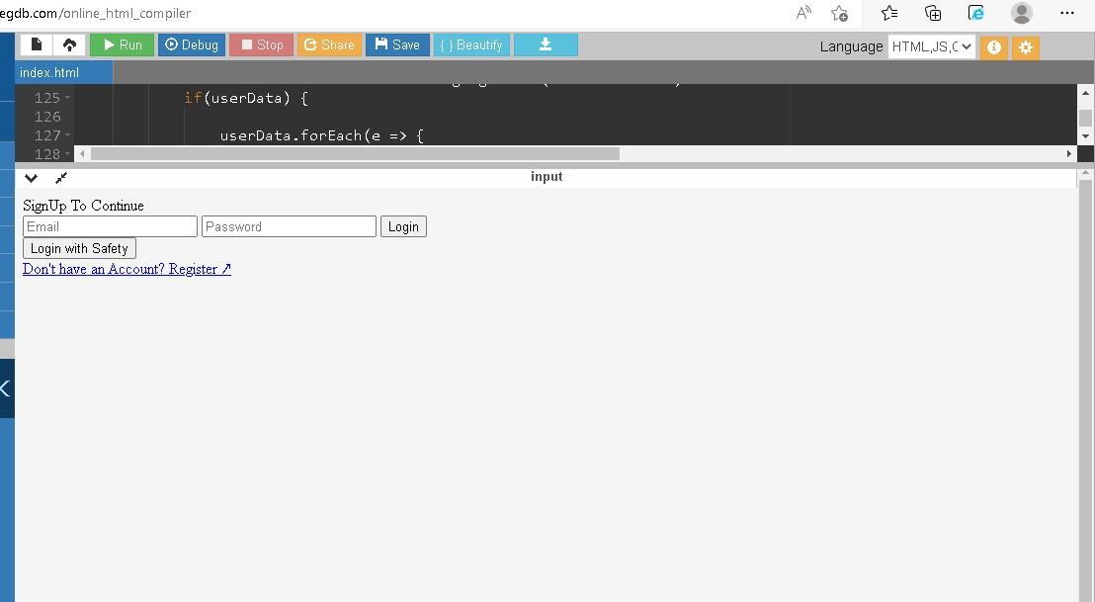

# CSS:

html, body {

}

height: 100%;

margin: 0;

font-weight: 300;

font-family: -apple-system, BlinkMacSystemFont, "Segoe UI", Roboto, Oxygen, Ubuntu, Cantarell, "Open Sans", "Helvetica Neue", sans-serif;

.wrapper {

height: 100%; display: flex;

align-items: center;

justify-content: center;

}

.loginContainer {

display: flex;

flex-direction: column; gap: 1rem;

min-width: 25rem; padding: 1rem 3rem;

border: 1px solid #44444444;

box-shadow: 0px 3px 2px 1px #44444444; border-radius: 8px;

}

.loginContainer span {

text-align: center; font-size: 3rem; font-weight: 500;

margin: 1rem 1rem 3rem;

}

.traditionalLoginContainer form { display: flex;

flex-direction: column; align-items: center;

justify-content: center;

}

.traditionalLoginContainer :is(input[type="text"], input[type="password"], input[type="email"]) { margin: 0.3rem;

padding: 0.3em 0.5em; border: 1px solid #44444444; border-radius: 5px;

outline: none; min-width: 200px;

font-size: 1.3rem;

}

.traditionalLoginContainer .loginButton { background-color: #0070f3; font-size: 1.6rem;

padding: 0.2em 0.8em; color: white;

margin: 0.4rem; border: none; border-radius: 5px;

cursor: pointer;

margin-top: 2rem;

}

.traditionalLoginContainer .loginButton:hover {

background-color: #0071f3d6;

}

.loginWithFireContainer {

display: grid; display: -ms-grid;

place-items: center;

}

.fire {

background-color: #f8f9fa; border: 1px solid #3c404321; border-radius: 4px;

color: #3c4043;

font-family: arial, sans-serif;

margin: 11px 4px; padding: 0.4em 0.8em; line-height: 27px;

min-width: 54px; text-align: center; cursor: pointer; user-select: none; font-size: 1.3rem; font-weight: 500;

}

.hyperLink {

text-decoration: none; text-align: center;

font-size: 1.2rem; color: #0070f3;

font-weight: 400;

}

@media screen and (max-width: 480px) {

.loginContainer { border: none;

box-shadow: none; min-width: fit-content;

min-width: -moz-fit-content; min-width: -webkit-fill-available; padding: 1rem;

}

}

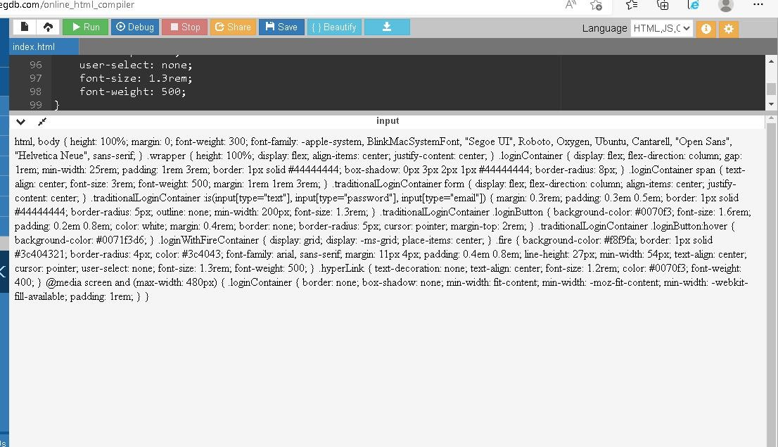

# DASHBOARD:

**HTML:**

<!DOCTYPE html>

<html lang="en">

<head>

<meta charset="UTF-8">

<meta http-equiv="X-UA-Compatible" content="IE=edge">

<meta name="viewport" content="width=device-width, initial-scale=1.0">

<link rel="stylesheet" href="./css/dashboard.css">

<title>Dashboard</title>

<script src="./localforage.js"></script>

</head>

<body>

<div class="wrapper">

<div class="header">

<span class="heading">Dashboard</span>

<span class="right">

<span class="username">Hello User</span>

<span>

<img class="profilePic" src="https://avatars.dicebear.com/api/avataaars/asdfasdfds.svg" alt="User Profile" height="30" width="30">

</span>

</span>

</div>

<div class="actionCenter">

<div class="action">

<span>Create Child Card</span>

</div>

<div class="action">

<span class="logout">Log out</span>

</div>

</div>

<div class="childCardContainer">

<div class="childCard">

<div class="childCardHeader">

<span>Child Name</span>

<span>Age 12</span>

</div>

<div class="actions">

<span>View</span>

<span>GeoFence</span>

</div>

</div>

</div>

</div>

<script>

async function main() {

let userData = await localforage.getItem('userData') if(userData == null) {

window.location.href = "/login"

}

document.querySelector(".username").innerHTML = `Hello ${userData.firstName}` document.querySelector(".profilePic").src = userData.profilePic

}

main()

document.querySelector(".logout").addEventListener("click", async () => { await localforage.setItem('userData', null)

window.location.href = "/login"

})

</script>

</body>

</html>

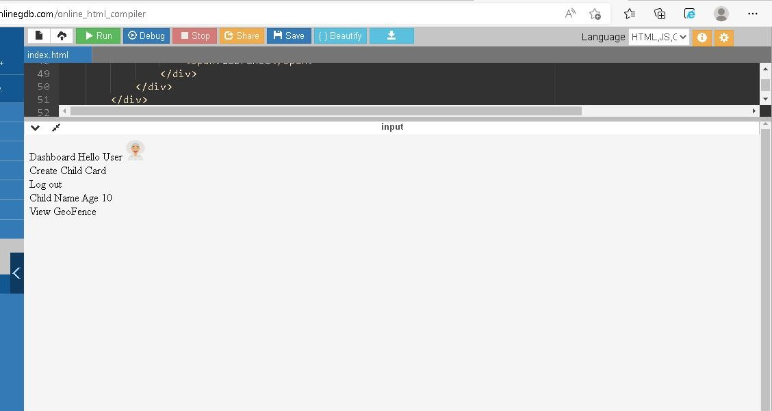

# CSS:

html, body { margin: 0;

padding: 0;

font-family: system-ui, -apple-system, BlinkMacSystemFont, 'Segoe UI', Roboto, Oxygen, Ubuntu, Cantarell, 'Open Sans', 'Helvetica Neue', sans-serif;

}

.wrapper { display: flex;

flex-direction: column;

height: 100vh; margin: 0 auto;

}

.header { display: flex;

justify-content: space-between; align-items: center;

padding: 1rem;

background-color: #f1f1f1;

}

.heading {

font-size: 1.3rem;

}

.right {

display: flex;

align-items: center; gap: 0.5rem;

}

.actionCenter { display: flex;

justify-content: flex-end; align-items: center;

gap: 1rem; padding: 0.5rem 0;

}

.actionCenter .action { padding: 0.5rem 0.8rem; border: 1px solid #44444444; border-radius: 12px;

margin-right: 0.5rem; cursor: pointer;

}

.actionCenter .action:hover { background-color: #0070f3; color: white;

}

.childCardContainer { display: flex;

flex-wrap: wrap; padding: 0.5rem 1rem;

}

.childCardContainer .childCard { display: flex;

flex-direction: column; border: 1px solid #44444444; border-radius: 12px;

max-width: 300px;

font-size: 1.4rem;

}

.childCardContainer .childCard .childCardHeader { display: flex;

gap: 3rem;

margin: 0.1rem 0.1rem 0.8rem; padding: 1rem 0.8rem 0;

}

.childCardContainer .childCard .actions { background-color: #0070f3;

padding: 2rem 0.5rem 1rem; color: white;

display: flex;

justify-content: space-around; border-radius: 12px;

border-top-left-radius: 0;

border-top-right-radius: 0;

}

.childCardContainer .childCard .actions span { border: 1px solid #0070f3;

background-color: white; color: #0070f3;

padding: 0.3rem 0.9rem; border-radius: 12px;

cursor: pointer;

}

